Fully Inclusive European Tours
All Done for You...
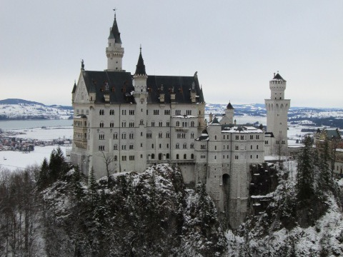
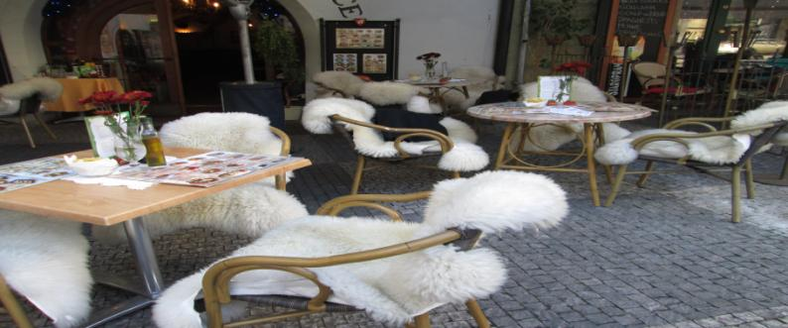
Could this be the best 30 days of your life?
Music Masters - Good Kings - Revolution - Romance
Commences Vienna 22nd January to 20 February 2014 Prague/Vienna
Vienna* Budapest* Bled* Salzburg* Neuschwanstein* Munich* Prague*

30 Day Fully Inclusive European Adventure

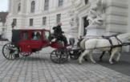
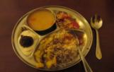
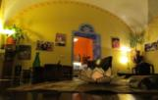
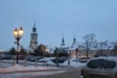
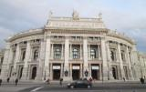
Experience Bohemia and Bavaria in an Exciting Adventure like never before
Enjoy a Uniquely Different European Experience
With Our 30 Day Fully Inclusive Tour

When you travel with our destinations experts, you will experience a journey you will long remember.  You will explore hidden gems of historical significance and dine with locals to hear stories of their cities from their own lips.  You will bathe in thermal springs, ride a gondola in the Austrian slopes, dine underground in a 700 year old cavern or just sit and enjoy the views over a world class local beer, wine or coffee.  No matter the trips you have done before, you have not experienced the heart or soul of these vibrant and beautiful areas until you have taken this 30 day fully inclusive, behind the scenes trip.  This is not your usual run of the mill European bus or river cruise trip where you are forever hopping on and off buses, skipping through cities at break-neck speed to spend another night in another hotel room. No cruising past cities in the night, wondering where on earth you are to-day!  We stay put in key locations from 8 big days in Prague to 11 bigger days in Vienna, in twin share apartment rooms where our own tour cook will conjure up daily treats, supply pre-dinner drinks and look after you like never before.  We also quickly visit a few places you simply cannot miss on a fairytale Bavarian stopover for 3 pristine days in Bled and 5 days between Salzburg-Munich, ending with 9 days in Prague.  All up a journey like no other you have ever experienced. You will come away with a deeper appreciation of the real history of these beautiful European historical centres and hopefully will have formed lasting friendships.  Spend 11 days in elegant Vienna in our twin share apartments, with built in cook who accompanies us for the entire 30 days.  Visit Palaces, (Schonnbrun, Belvedere, Hofburg) see Museums and Castles, attend Music Masters concerts, relive the romance of an era at a Ball in a real Palace, visit the Prata where the “Third man” (Harry Lime Theme) was filmed, see Mozart’s house and savour delicious Viennese pastries and coffee afterwards.  Then with only an overnight bag, we pop over to Budapest for 2 days, leaving our gear in Vienna and rest up and kick back a bit at a slower pace. Just bathing in hot springs, cruising the Blue Danube, marvelling at the beautiful buildings untouched by wars of the past.  We visit Hero’s Square where Michael Jackson performed and generally chill out here for a few quieter days and catch up on your blogging lessons. Then we travel 3 hrs back to Vienna to continue our jaunt there. 2xN (B only for these 2 days) All entrances incl in Budapest.  Back in Vienna...Eat the biggest Weiner Schnitzel in the world, visit the ornate State Opera House. Step back into history with a visit to Good King-Emperor Franz Joseph’s Residence. We see Sissi’s Imperial apartments, crown jewels, dine with the locals and much more. 11xN(BLD) Entrances incl.  3 Days in Bled, in Slovania, the pristine capital down from the Bohemia/Lower Bavarian areas. Twin Share Budget accommodation here, where the amazing host collects us at the train station and takes us to our accommodation.  Next day we tour the area with our host, by mini-van to see sights tourists do not get to see very often. We visit the 1,002 year old Castle atop a vertical rock, the chapel in the glacial lake, gorges and caves of this pristine undiscovered haven. 3xN (BLD) All entrances incl.  Then we head off to Munich by train, in Lower Bavaria, visiting places you have only dreamed about. We visit Oberamagau, the Passion Play town, Linderhauf Castle, explore Munich City, Neuschwanstein Castle, Oktoberfest site, 2xN (2B,1D) All entrances incl.  Next we head to Salzburg to take a tour around the city, the Fortress and lakes area of Austria, passing Red Bull HQ to visit the world famous setting for the highly acclaimed Sound of Music classic film. Salzburg is the picture perfect setting and you will be captured by the beauty of this sparkling city. 3xN (BLD) All entrances incl.  Then off for 9 glorious days in the capital of Bohemia, Prague. There we delve into European history from 1,000 years ago up to the famous Velvet Revolution days of just over 20 years ago.  Magic cobblestoned footpaths, cut and paved by hand, the charming Old City, Astronomical Clock, Charles Bridge from the Tower. Dine in a 700 year old cavern, be shocked at the ancient torture instruments in Prague Castle and fall in love with the quaint houses in the golden street.  Shoot a crossbow, enjoy a hot “grog” back of the Castle, marvel at the myriads of swans on the river Vltava, go ghost hunting at night around the tiny back streets (guided tour) and spend the last evening with a Farewell Cocktail Party to reminisce about your extraordinary 30 day European adventure 8xN(BLD) All entrances incl. | 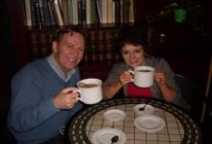  - Small tour groups of 10 to 15  - Longer term stays in Major Areas, with day visits to surrounding areas  - No packing and unpacking every day!  - 80 of 86 Meals Included  - Drinks served with in house evening meals  - 29 nights twin share accommodation  - All land transportation between cities  - 2 daytime river cruises  - 2 Music Masters concerts  - Mass with Vienna Boys/Men’s Choir  - Attendance Vienna Hofburg Palace for Europe’s finest Ball  - Pre-Ball Gala Dinner, Prata Buffet Brunch  - Entrance to Museums, Palaces and Castles  as scheduled  - City Orientation Bus Tours  - Organised walking tours in each city  - Private Gorges Tour in Lake Bled  - Bonus Blogging Workshop and Martini making course  - No Tipping Required  - Much more included...see full details on website  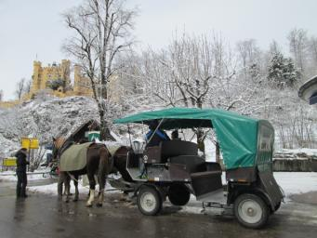  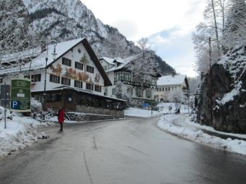  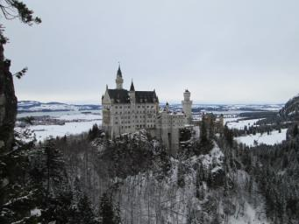  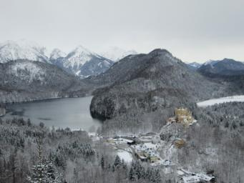  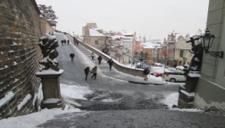  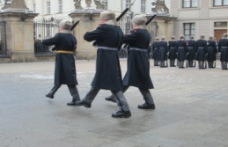  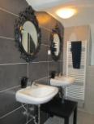  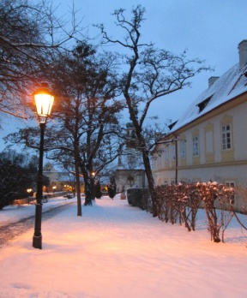  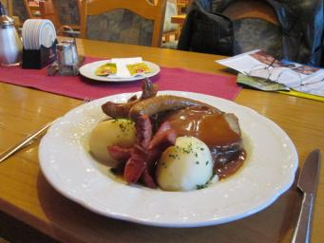  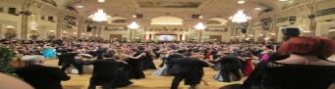  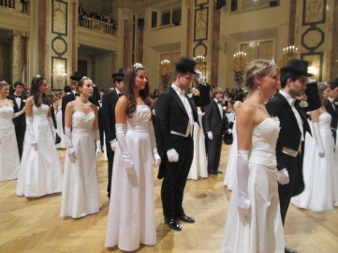  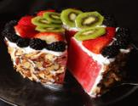  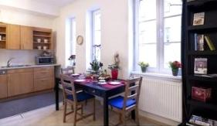  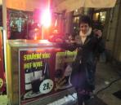  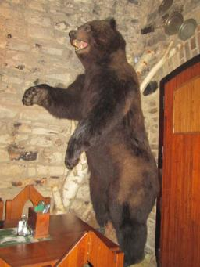  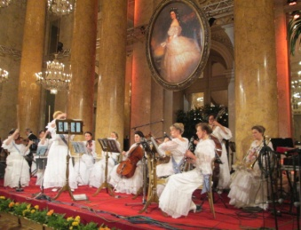  Begins Vienna - Ends Prague  You can ask us to help arrange transport to UK or other destinations for you if desired or we can help you with transport to your departure point.  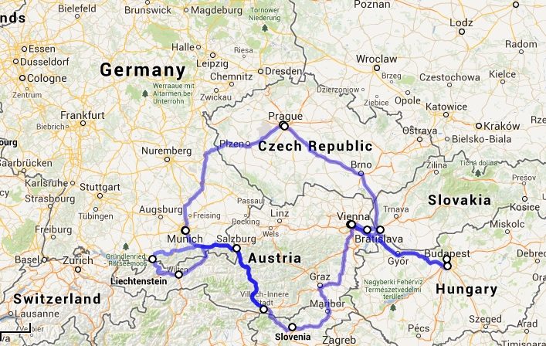  Inclusions...  - Twin Share Accommodation in Apartments  - 29 nights Land Tour price, fully inclusive of entrances, meals and travel as listed ...$4987  - Private room supplement $870 Ausd for 29 nights  - $200 Deposit to secure your place  - All tickets must be fully paid for no later than November 30th 2013  - You may pay Tour in easy weekly, fortnightly or monthly payments  - Note...This is a Land only tour price  - Add transport costs to and from Vienna to your home departure point  - Full detailed itinerary available on website  - All prices per person in Australian dollars.  Terms and Conditions. While we aim to visit all areas and activities mentioned in this brochure and on the tour website, we reserve the right to alter the sequence of cities visited if weather or unforeseen circumstances occur. If inclement weather forces any activity planned to be unavailable, an alternative activity of similar value will be substituted in an area of similar interest. 80 of 86 meals included, plus entrances to Castles, Concerts, Cruises, Vienna Ball, Museums included as described in full detail on website,  Visit our website www.tourlowerbavaria.weebly.com for more tour details for this fully inclusive 30 day European journey which could easily become the best 30 days of your life!

